**Question**

1. a) Consider a coke machine that has 10 slots. The producer is the delivery person and the consumer is the student using the machine. We use the following three semaphores:

* semaphore mutex
* semaphore fullBuffer /* Number of filled slots */
* semaphore emptyBuffer /* Number of empty slots */

The following operations are available on the semaphores: wait(semaphore s),signal(semaphore), Given functions (see code) delivery_person() and student():

* What will be the initial values of the semaphores?
* Write a solution that guarantees mutual exclusion and no deadlocks. (Part of the student () function has been written)

/* Initialize */

#define NUM_SLOTS 10

semaphore mutex =??

semaphore fullBuffer =??

semaphore emptyBuffer =??

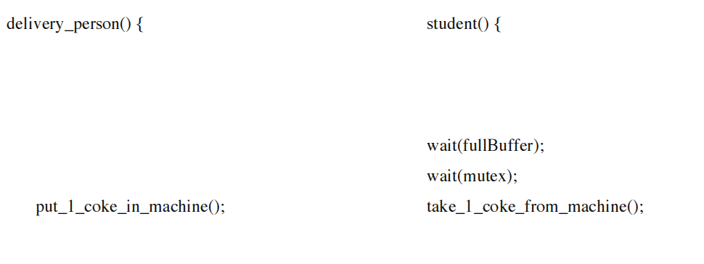

**} }**

b) If the two wait() functions inside the student() section are interchanged [i.e., wait(fullbuffer) and wait(mutex) are interchanged], will your solution to the previous question will still be correct ? If not, explain your reason?